PRACTICAL 4

PRACTICAL TITLE :- JavaScript DOM Manipulation, Event Handling, and UI Interactivity

Problem Definition Add dynamic UI components such as collapsible FAQ, modal popup,
image/content slider, notification banner, hamburger menu, and light/dark
theme switcher using JavaScript.

Key Questions / Analysis
/ Interpretation

1. How are DOM elements selected and modified?
2. Are event listeners attached correctly?
3. Is localStorage used for remembering theme choice?
4. Does interactivity improve usability without breaking accessibility?

Key Skills to be
Addressed

DOM selection, event handling, class manipulation, localStorage, basic
animation

Applications Interactive dashboards and dynamic frontend behaviour
Learning Outcome Students will apply JavaScript to enhance user experience and client-side

interactivity.
Dataset/Test Data Static FAQ/event content
Tools/Technology to be
Used

JavaScript ES6+, HTML5, CSS3, browser dev tools
Total Hours Implementation: 4 hours | Total engagement: 6 hours
Post Laboratory Work
Description

Submit live demo and source-code explanation.

Evaluation Strategy
Including Viva

DOM logic, event handling correctness, usability, and browser console
testing.
Advanced/Intermediate
Extension

Intermediate: Add transition effects to cards/buttons.
Advanced: Store user UI preferences in localStorage and restore them on
page load.

GIT HUB REPOSITORY LINK :-

https://github.com/nehalvala0005-cloud/sh.git

1. Aim
To implement JavaScript DOM manipulation, event handling, and UI interactivity by creating dynamic components such as a collapsible FAQ, modal popup, image/content slider, notification banner, hamburger menu, and light/dark theme switcher.

2. Problem Definition
Add dynamic UI components such as:
- Collapsible FAQ
- Modal popup
- Image/content slider
- Notification banner
- Hamburger menu
- Light/Dark theme switcher
Use JavaScript to manipulate DOM elements and handle user interactions.

3. Key Questions / Analysis
- How are DOM elements selected and modified?
- Are event listeners attached correctly?
- Is localStorage used for remembering the theme choice?
- Does interactivity improve usability without breaking accessibility?

4. Key Skills / Concepts Used
- DOM Selection
- DOM Manipulation
- Event Handling
- addEventListener()
- Class Manipulation
- classList
- localStorage
- JavaScript ES6+
- Basic CSS Animation

5. Tools / Technologies Used
- HTML5
- CSS3
- JavaScript ES6+
- Visual Studio Code
- Web Browser
- Browser Developer Tools

6. Theory
DOM Manipulation
DOM stands for Document Object Model. It represents an HTML document as a tree of objects. JavaScript can select and modify these objects dynamically.
Example:
document.getElementById("title").textContent = "StudentHub";
Event Handling
JavaScript events allow a webpage to respond to user actions such as:
- Click
- Mouse movement
- Keyboard input
- Form submission
Example:
button.addEventListener("click", function() {
alert("Button clicked!");
});
localStorage
localStorage allows data to be stored in the browser so that it can be used even after refreshing the page.
Example:
localStorage.setItem("theme", "dark");

7. Implementation
The following components were implemented using HTML, CSS and JavaScript:
A. Collapsible FAQ
When the user clicks a question, the answer is displayed or hidden.
B. Modal Popup
A popup window is displayed when the user clicks a button.
C. Content Slider
Users can move between different pieces of content using navigation buttons.
D. Notification Banner
A notification message is displayed to inform the user about an update.
E. Hamburger Menu
A navigation menu is opened and closed using a menu button, especially useful on smaller screens.
F. Light/Dark Theme Switcher
The user can switch between light and dark themes. The selected theme is stored using localStorage.

8. Sample JavaScript Code
const faqButton = document.getElementById("faqButton");
const faqAnswer = document.getElementById("faqAnswer");

faqButton.addEventListener("click", function() {
faqAnswer.classList.toggle("show");
});

const modal = document.getElementById("modal");
const openModal = document.getElementById("openModal");
const closeModal = document.getElementById("closeModal");

openModal.addEventListener("click", function() {
modal.style.display = "flex";
});

closeModal.addEventListener("click", function() {
modal.style.display = "none";
});

const menuButton = document.getElementById("menuButton");
const menu = document.getElementById("menu");

menuButton.addEventListener("click", function() {
menu.classList.toggle("active");
});

const themeButton = document.getElementById("themeButton");

themeButton.addEventListener("click", function() {

document.body.classList.toggle("dark");

if (document.body.classList.contains("dark")) {
localStorage.setItem("theme", "dark");
} else {
localStorage.setItem("theme", "light");
}

});

window.addEventListener("load", function() {

const savedTheme = localStorage.getItem("theme");

if (savedTheme === "dark") {
document.body.classList.add("dark");
}

});

9. Algorithm
Step 1
Create the required HTML elements for FAQ, modal, slider, notification, menu and theme switcher.
Step 2
Select the required DOM elements using JavaScript.
Step 3
Attach event listeners to buttons and interactive elements.
Step 4
Use classList to add or remove CSS classes dynamically.
Step 5
Use JavaScript to display and hide the modal and FAQ content.
Step 6
Implement the hamburger menu using class manipulation.
Step 7
Implement light/dark theme switching.
Step 8
Store the selected theme in localStorage.
Step 9
Restore the saved theme when the webpage is loaded.
Step 10
Test all interactive components using the browser.

10. Expected Output
The webpage should provide the following functionality:
Component | Expected Behaviour
FAQ | Answer opens/closes on click
Modal | Popup opens and closes
Slider | Content changes using navigation
Notification | Notification banner is displayed
Hamburger Menu | Navigation opens/closes
Theme Switcher | Light/Dark mode changes
localStorage | Theme remains after page refresh

11. Testing
Test Case 1 – FAQ
Action: Click FAQ question
Expected: Answer should appear.
Test Case 2 – Modal
Action: Click Open button
Expected: Modal popup should appear.
Test Case 3 – Hamburger Menu
Action: Click menu button
Expected: Navigation menu should open/close.
Test Case 4 – Theme Switcher
Action: Click theme button
Expected: Page theme should change.
Test Case 5 – Theme Persistence
Action: Select dark theme and refresh page
Expected: Dark theme should remain selected.

12. Result
The JavaScript DOM manipulation and event handling features were successfully implemented. Interactive UI components such as FAQ, modal popup, content slider, notification banner, hamburger menu and light/dark theme switching were demonstrated.
The use of localStorage successfully allows the selected theme preference to be remembered after page refresh.

13. Learning Outcome
After completing this practical, I learned how to:
- Select and modify DOM elements using JavaScript.
- Handle user events using event listeners.
- Dynamically add and remove CSS classes.
- Create interactive UI components.
- Use localStorage to store user preferences.
- Improve frontend usability using JavaScript.

PROOF OF WORK :-

4.1 :- Normal StudentHub Page

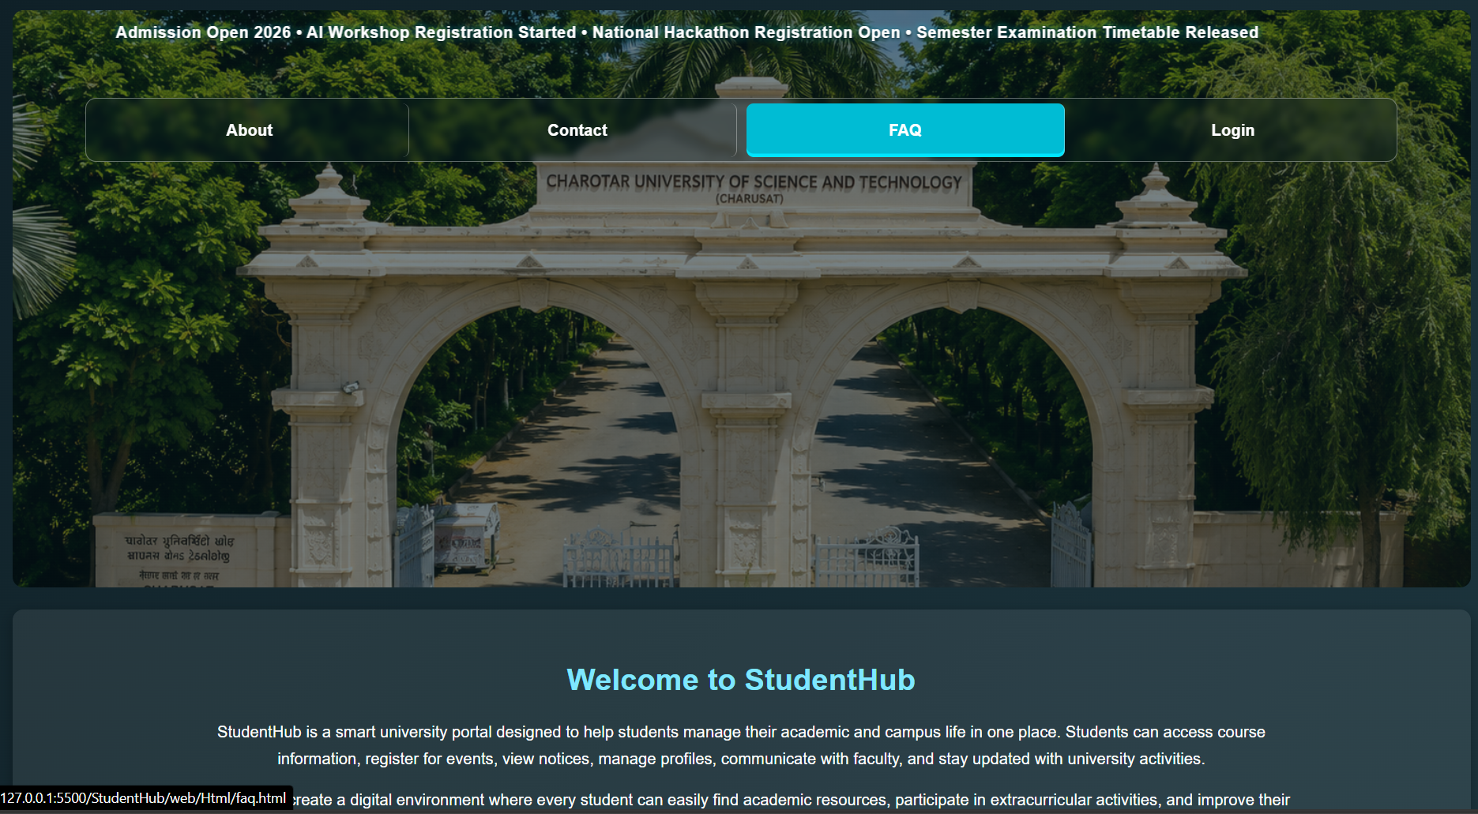

4.2 :- FAQ open
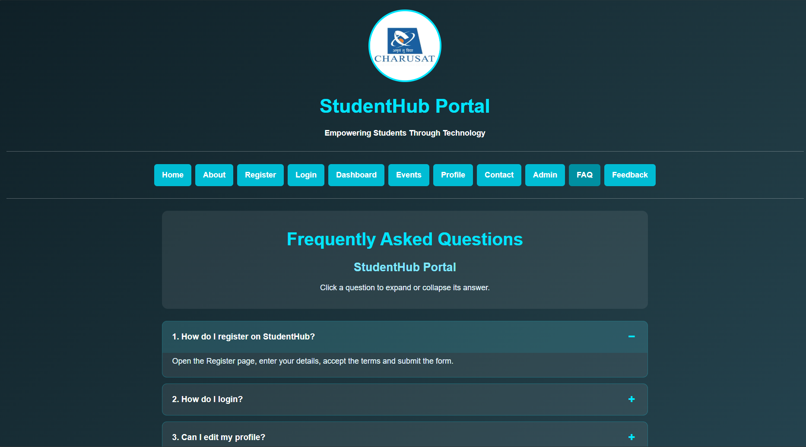

4.3 :- Modal Popup
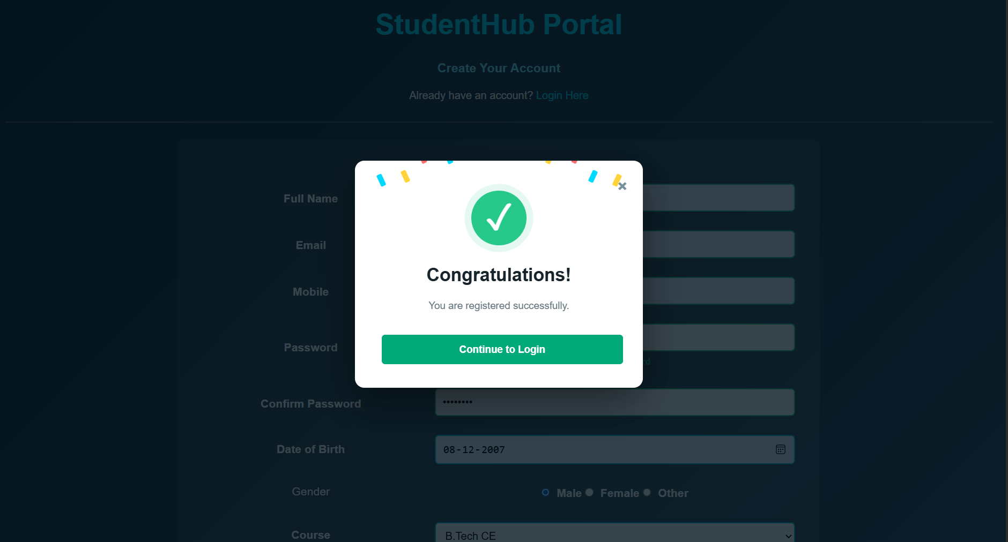

4.4 :- Notification Banner
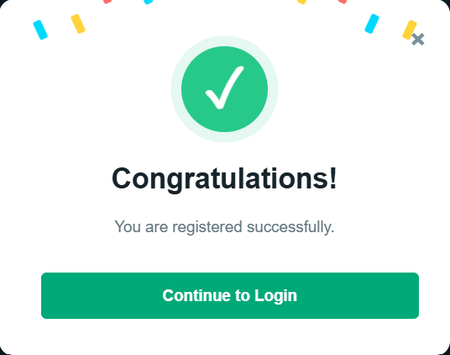

Learning Outcomes
After completing this practical, I was able to:
- Understand the basics of JavaScript DOM manipulation.
- Implement event handling for interactive webpage elements.
- Create and manage dynamic popups and notifications.
- Improve webpage user interaction and responsiveness using JavaScript.
- Understand how JavaScript can dynamically modify HTML elements and their properties.
- Develop a better understanding of creating interactive web applications.

Conclusion
Thus, JavaScript DOM manipulation and event handling were successfully implemented. Interactive components were created to make the StudentHub webpage more user-friendly and responsive. The practical helped in understanding how JavaScript can dynamically control webpage elements and respond to user actions.

Faculty Remark :- _____________________________________

